Process commands in Linux ➖

- ps command to view process
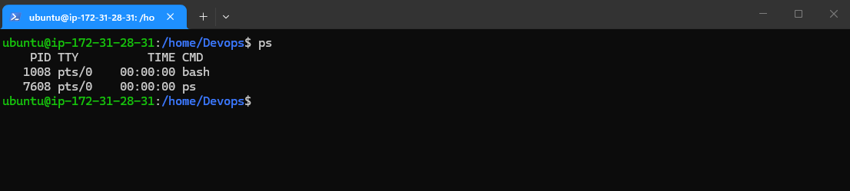

- Top command use to check CPU and Running Proccess

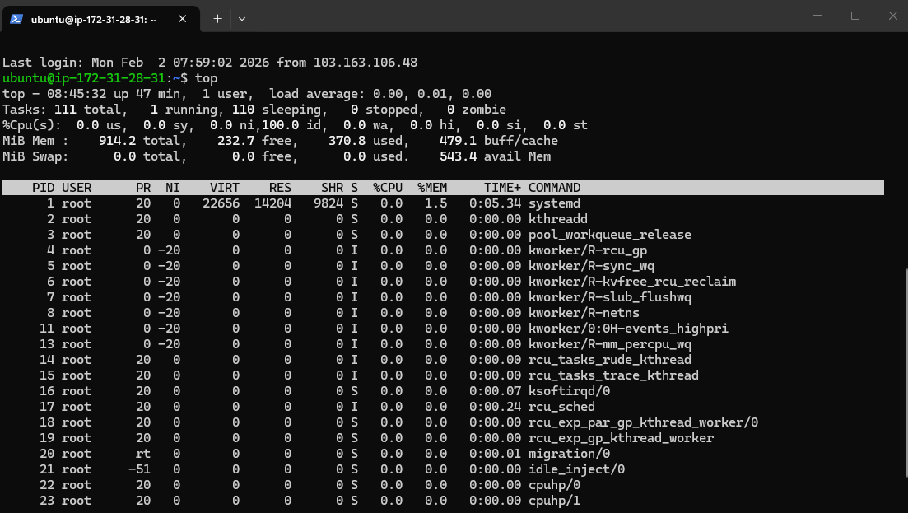

- To install Nginx System
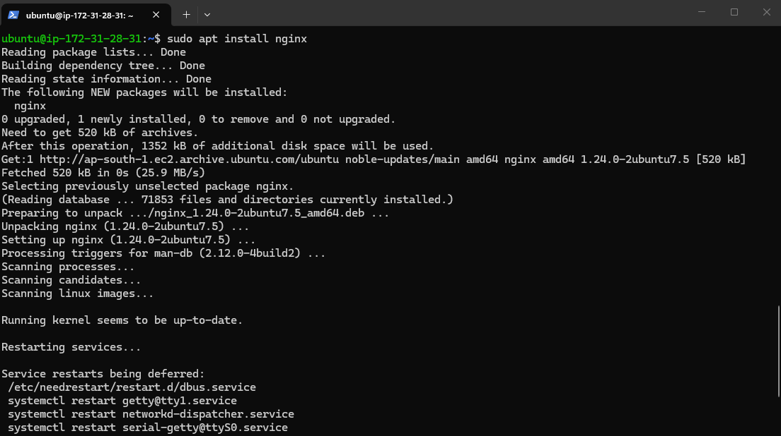
4. To check status of nginx server
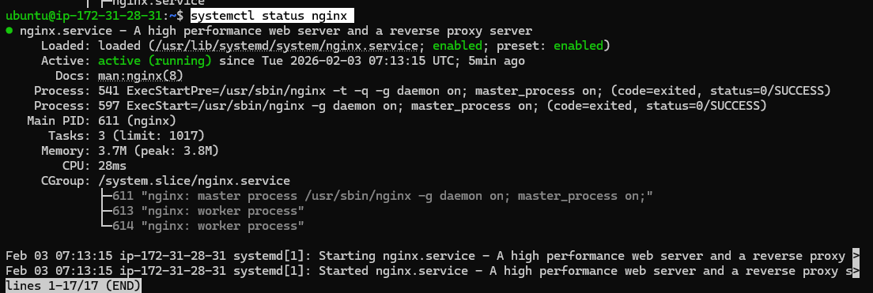

5. To check logs of Nginx server.
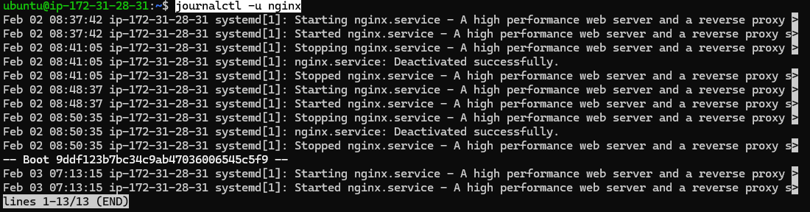

6 . To check last 10 lines of any file
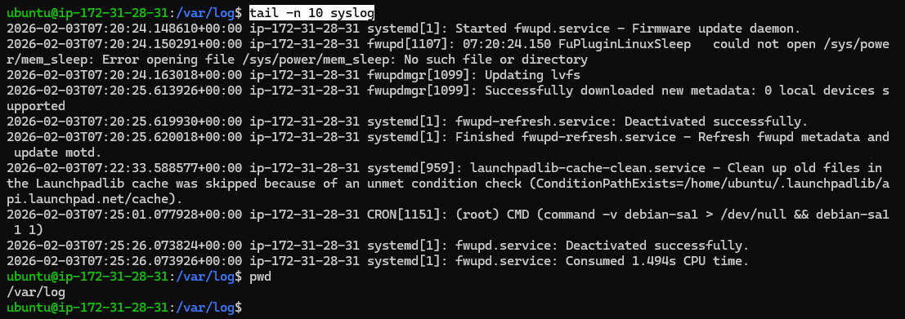

7. To Check whether DNS is working or not. 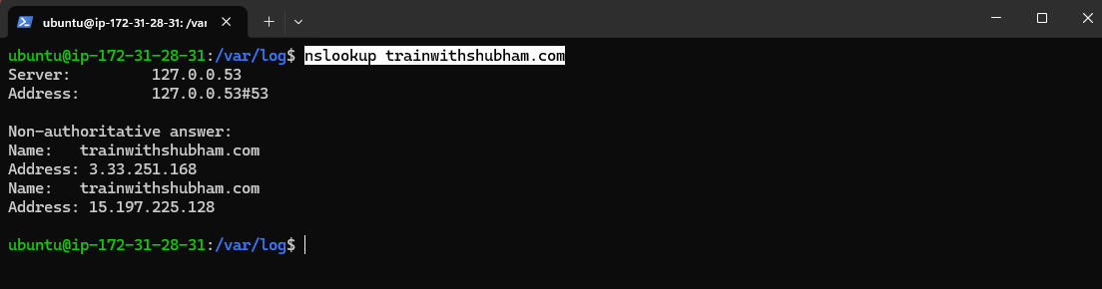

8. To check most recent error in system.
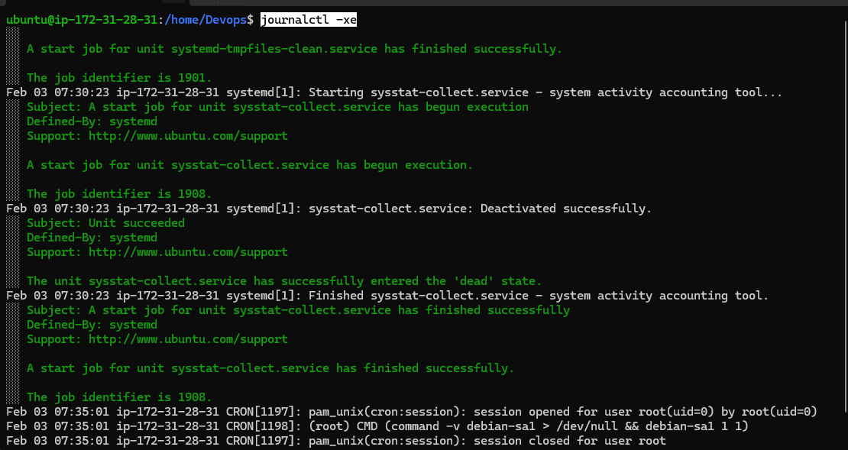

9. To watch system messages in real-time.
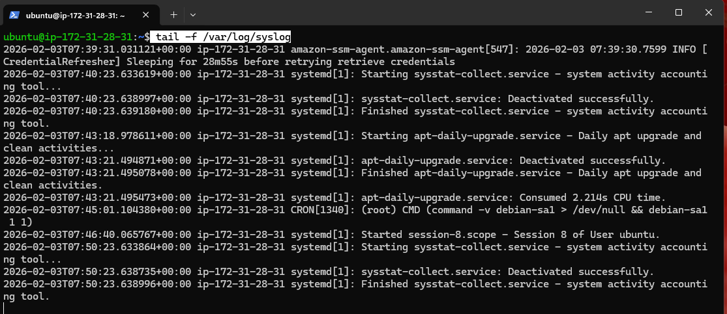

10 . Created a .sh file to immediate server shutdown.
